Attendance Related Discipline

All attendance discipline grievances should cite ELM 513, Article 10, 16, 19 and M-39 section 115

Firstly, the NALC should address the negotiated benefit of sick leave.

Article 10

Article10 section 5 states in relevant part,

10.5 Section 5. Sick Leave
The Employer agrees to continue the administration of the present sick
leave program, which shall include the following specific items:
A. Credit employees with sick leave as earned.
B. Charge to annual leave or leave without pay (at employee’s
option) approved absence for which employee has insufficient
sick leave.
C. Employee becoming ill while on annual leave may have leave
charged to sick leave upon request.
D. For periods of absence of three (3) days or less, a supervisor may
accept an employee’s certification as reason for an absence.
Sick Leave. Article 10.5 provides for the continuation of the sick leave
program, whose detailed regulations are contained in ELM Section
513. Section 513.1 defines sick leave as leave which “insures employ-
ees against loss of pay if they are incapacitated for the performance of
duties because of illness, injury, pregnancy and confinement, and medi-
cal (including dental or optical) examination or treatment.”
Sick Leave.

The Employer agrees to continue the administration of the present sick leave program, which shall include the following specific items:

- Credit employees with sick leave as earned.

ELM 513

ELM 513 states in relevant part,

513 Sick Leave

513.1 Purpose

513.11 Sick Leave for Employee Incapacitation
Sick leave insures employees against loss of pay if they are incapacitated for the performance of duties because of illness, injury, pregnancy and confinement, and medical (including dental or optical) examination or treatment.

Sick leave for full time letter carriers is accrued at 4 hours per bi-weekly pay period, or 13 days per year. As stated above, this benefit is negotiated to insure employees against loss of pay if they are incapacitated.

Article 16 - Just Cause Principle

Is there a rule? In the case of attendance abuse, there is no set standard to hold a carrier accountable. Each individual employee must be dealt with on a case by case basis. A certain number of absences cannot automatically trigger discipline. Also, past absences cannot be questioned as legitimate if they were not done so at the time of the incident. (C-04163, M-00296, M-00500, C-29554).

Is the rule consistently and equitably enforced? Have other employees been treated differently? Has the employee's own discipline record remained unchanged and management is suddenly imposing discipline? (C-16237, C-16970)

Was a thorough investigation completed? Are the dates and incidents factually correct? (C-08386). Are any of the incidents related to an on-the-job injury? (C-04024). Are any of the absences FMLA covered? (M-01270, C-16970, C-14107). Does the employee have problems related to alcohol or drug abuse? (C-25874).

Was the severity of the discipline reasonably related to the infraction itself and in line with that usually administered, as well as to the seriousness of the employee’s past record? Progressive discipline is necessary in irregular attendance discipline. (C-09766). Is management trying to use separate tracks of discipline to include attendance? (C-06299, C-24238, C-25994, C-26238, C-27859).

Was the disciplinary action taken in a timely manner? Disciplinary actions should be taken as promptly as possible after the offense has been committed. In the issue of attendance discipline, going back more than three months to address an attendance issue leaves the question open as to why attempts to improve the carrier’s performance were not taken sooner? Even an official discussion reaching back more than three months should be documented by the steward to support this defense.
.
M-39 section 115.3 and Corrective Discipline

M-39 section 115.3c.
The manager has the responsibility to resolve as many problems as
possible before they become grievances.

Article 16 section 1. principles
In the administration of this Article, a basic principle shall be that discipline
should be corrective in nature, rather than punitive.

Within these two cites we have the strongest defense against attendance discipline. Very rarely does management take every effort to correct attendance issues before moving on to discipline.

The ELM specifically calls for a restricted sick leave program to correct attendance issues. While the ELM states that management may place an employee on the restricted list if they have evidence pointing to sick leave abuse, the tenets of corrective discipline demand it. If management overlooks an opportunity to correct an issue before handing out discipline, they are giving us a grievance victory.

ELM 513.391 Reasons for Restriction Supervisors or installation heads who have evidence indicating that an employee is abusing sick leave privileges may place the employee on the restricted sick leave list. In addition, employees may be placed on the restricted sick leave list after their sick leave use has been reviewed on an individual basis and the following actions have been taken:
- Establishment of an absence file.
- Review of the absence file by the immediate supervisor and higher levels of management.
- Review of the absences during the past quarter of LWOP and sick leave used by employees. (No minimum sick leave balance is established below which the employee’s sick leave record is automatically considered unsatisfactory.)
- Supervisor’s discussion of absence record with the employee.
- Review of the subsequent quarterly absences. If the absence logs indicate no improvement, the supervisor is to discuss the matter with the employee to include advice that if there is no improvement during the next quarter, the employee will be placed on restricted sick leave.

513.392 Notice and Listing Supervisors provide written notice to employees that their names have been added to the restricted sick leave listing. The notice also explains that, until further notice, the employees must support all requests for sick leave by medical documentation or other acceptable evidence (see 513.364).

513.393 Recision of Restriction Supervisors review the employee’s PS Form 3972 for each quarter. If there has been a substantial decrease in absences charged to sickness, the employee’s name is removed from the restricted sick leave list and the employee is notified in writing of the removal.

With the RMD/eRMS automated sick leave call in program, management can implement restricted sick leave at the click of a button. Calling it being placed on the “deems desirable list” does not change the fact that the ELM requirements for implementing restricted sick leave still apply. (M-01468, M-01597)

Other Arguments

"Employers cannot discipline employees for absences which are legitimately caused by the physical incapacity of an employee up to at least the point where the employee exhausts his/her accumulated sick leave benefits." (C-00599). In C-03231, Arbitrator Garrett stated that on a case by case basis, pre-approved sick leave instances can be used to support excessive absenteeism discipline. This is defendable! Firstly, Garrett used the just cause argument to filter whether a pre-approved absence can be used for discipline. Bottom line – if the reason for the absence is legitimate, it should not be used. Also, MSPB rules for attendance related discipline differ from the "just cause" principles of the National Agreement. They prohibit consideration of absences on "approved" sick leave as a basis for absenteeism discipline. Arbitration C-02099 concludes that failure to notify employees that excused absences will be used as the basis for discipline undermined management's argument that the employee was aware of the consequences of her actions (just cause). There is also the issue of disparate treatment if other employees are not disciplined for excused absences.

The PDI
During a PDI, stewards should go on the offensive and ask questions that management cannot answer or if they do answer, will serve to formulate arguments in the grievance procedure. What constitutes irregular attendance? What are the attendance requirements? What opportunity did you give this employee to show improvement? These questions must be tailored to the grievant and his/her attendance record and circumstances.
If management tries to establish a pattern of using sick leave in conjunction with non-scheduled days, cite the following chart. Make sure to factor in any holidays as well.

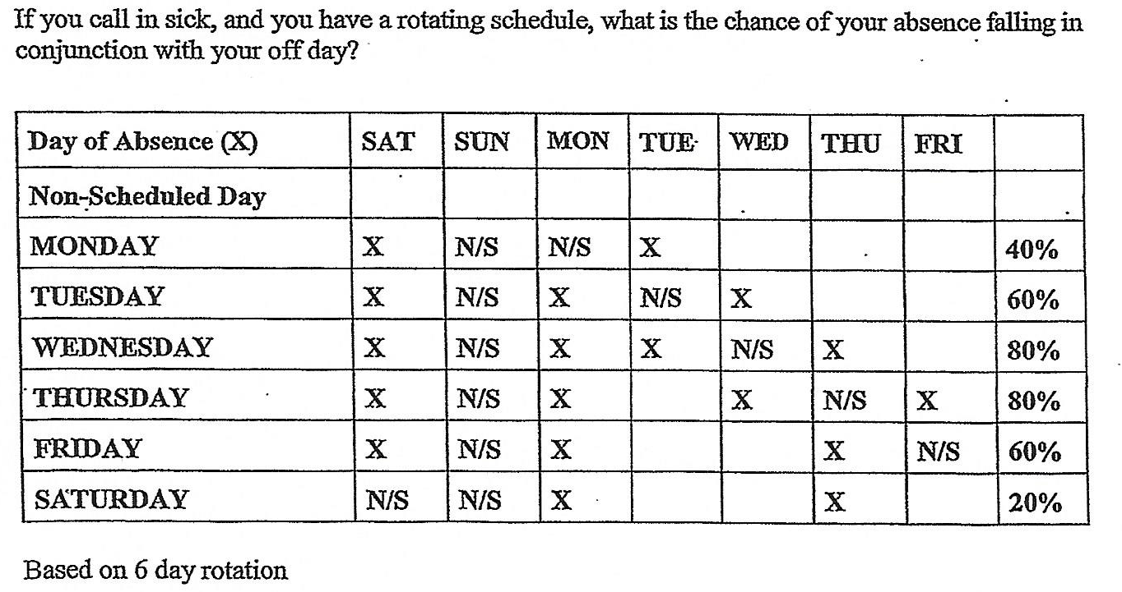

Request for Information

The following is a good list to start off with when handling attendance discipline. Some may not apply to your case, but most of it will. This information should be requested and received before meeting at Informal A. Being thorough with this information request makes it uncomfortable for management to continue issuing discipline of this nature.

- Letter of Discipline
- Copies of all prior discipline cited
- PS Form 3971 for all absences
- PS Form 3972 for previous 2 years
- ERMS Key Indicator Report for current and previous year
- Medical Documentation submitted for any cited absence
- PDI notes from supervisor
- Documentation of attendance reviews
- Detailed statement from grievant
- Installation absence percentage for current and previous year
- Restricted Sick Leave/ERMS Deems Desirable List
- EAP Referral record
- FMLA Documentation

Article 19 should always be included in a grievance, since anything cited other than the National Agreement and JCAM need to be incorporated into the contract via the language found there.

Article 19

Article 19 states in relevant part,

Article 19 Handbooks And Manuals

Those parts of all handbooks, manuals and published regulations of the
Postal Service, that directly relate to wages, hours or working condi-
tions, as they apply to employees covered by this Agreement, shall
contain nothing that conflicts with this Agreement, and shall be con-
tinued in effect except that the Employer shall have the right to make
changes that are not inconsistent with this Agreement and that are
fair, reasonable, and equitable.

On a final note, stewards should take away the focus on the negative and place it on the positive. Count how many days the carrier could have worked in the past 6 months (or choose a different period of time if it favors your argument). Now use the following formula;

Days employee was at work X 100, and then divided by the total number of possible days at work. This will give you an "attendance grade". As an example, if the carrier was absent 4 days in a 120 possible work day period, the formula would be 116 multiplied by 100, then divided by 120 . . . or 96.66%. So this carrier is being disciplined for being at work 96.66% of the time. That is a high "A" in any testing format and yet the Postal Service is giving the carrier a failing grade. Talk about this in your grievance.

